Encouraging Developers and Designers to Better Understand Accessibility
Presented by: Justin Eddings
Accessibility Guidelines
Frame them in a way that makes sense to a designer/developer
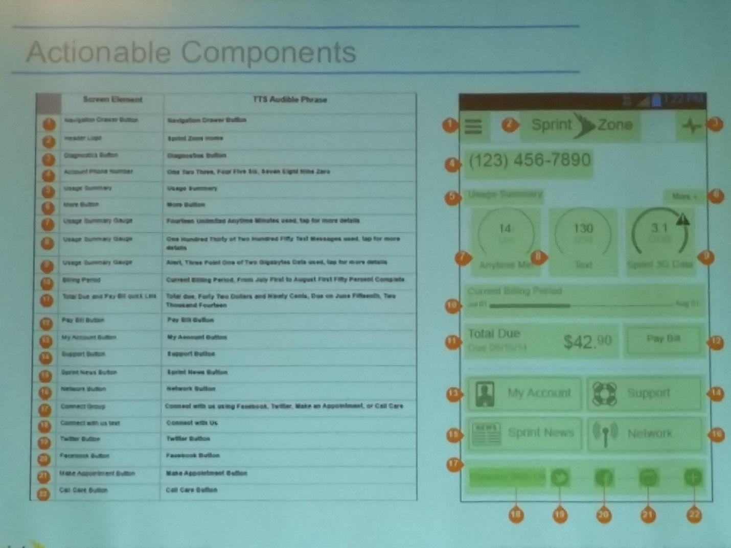
Tell people the same thing in multiple ways (include TTS Audible Phrases)
Transition (let people know that something is going on while they wait), pop-ups (make sure these work), and Numeric (if there’s an impact to the numeric, i.e. bill is about to be late, then tell them that too)
Dynamic content
Tab and Carousel (let people know that they’re on X of Y so they can slide if they need/want to)
Static content and menu links
Touch Ergonomics (how big things need to be)
Stephen Hoober (4ourth Mobile Touch Template) 4ourth.com - this is a physical overlay to assist with testing your touch screen interface.
Color, Contrast, and Saturation
WCAG 2.0 checklist broken down into beginner (A) and intermediate (AA) and summary of the guidelines https://www.wuhcag.com/wcag-checklist/
Contact information: Justin.eddings@sprint.com or @jeepyjayhawk on Twitter

